Assignment 1

**Inventory Management System**

Team ID : PNT2022TMID05660

Name : Naveen SABARINATH B

1. **Create registration page in html with username, email and phone number and by using POST method display it in next html page.**

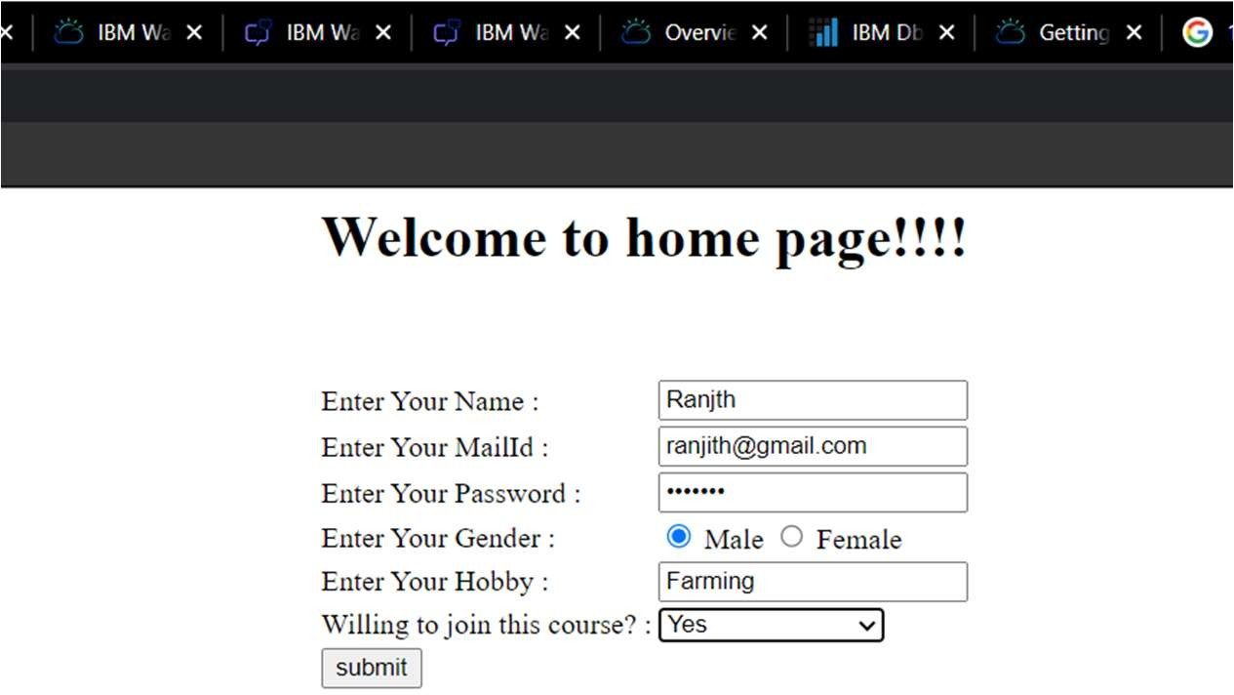

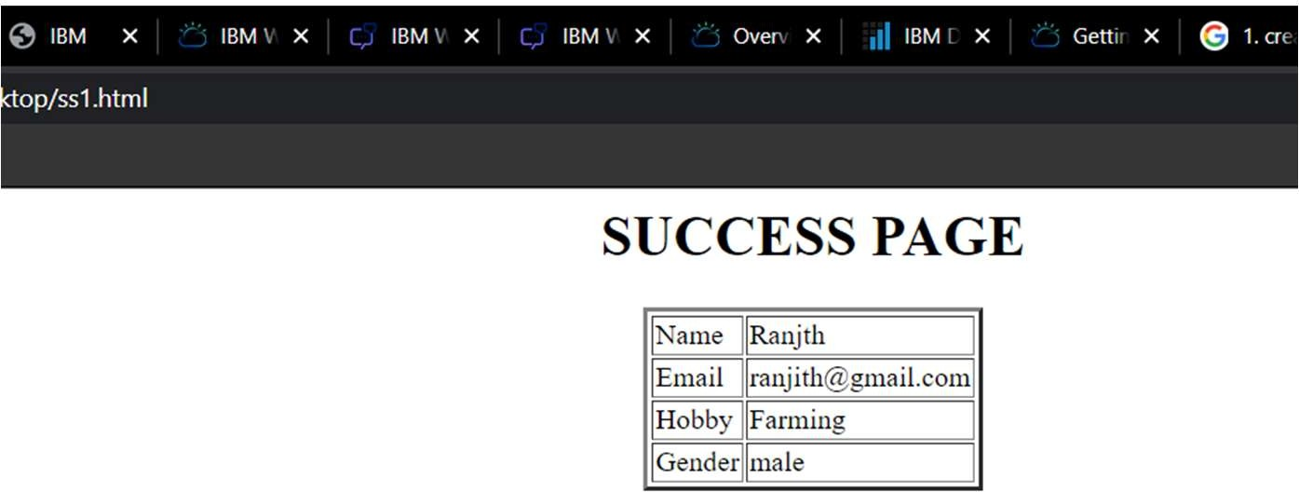

1. **Develop a flask program which should contain at least 5 packages used from pypi.org.**

import flask

from flask import Flask from flask import request from flask import json

app=Flask( name )

countries={"1":"India", "2":"China", "3":"New York" ,"4":"London" ,"5":"Paris"

,"6":"France" }

@app.route('/data',methods=['GET','POST']) def api():

if request.method=='GET': return countries

if request.method=='POST': data=request.json countries.update(data) return 'data got inserted'

@app.route("/data/<id>",methods=['PUT']) def update(id):

data=request.form['item'] countries[str(id)]=data return 'data updated'

@app.route("/data/<id>",methods=["DELETE"]) def deleteoperation(id):

countries.pop(str(id)) return 'data deleted'

if name ==' main__': app.run(debug=True)